TA 2 Submission

Title of the Experiment:
DNS Traffic Analysis using Wireshark

Submitted by:
Name Roll no. Branch/Sem Batch
Shourya Deshmukh | 63 | CSE/3 | B4
Sharvan Kotharu | 43 | CSE/3 | B3
Sujal Tembhare | 49 | CSE/3 | B3
Soumya Wasule | 38 | CSE/3 | B3

Aim / Objective
To analyze DNS traffic and detect simulated attacks such as DNS tunneling, spoofing, and data exfiltration using Wireshark.

Theory / Conceptual Background

DNS (Domain Name System) is responsible for translating human-readable domain names into IP addresses. However, attackers exploit DNS for malicious purposes such as tunneling, spoofing, and data exfiltration.
● DNS Tunneling
DNS tunneling hides secret data inside regular DNS requests, similar to sneaking a hidden message within a normal query. Attackers encode information in subdomains, making malicious activity appear normal. Wireshark can detect such activity through filters and observing unusually long or encoded subdomains.
● DNS Spoofing
DNS spoofing occurs when attackers send fake DNS replies to redirect users to malicious sites instead of legitimate ones. Wireshark helps identify spoofing through mismatched IP addresses or suspicious timing patterns in DNS responses.
● DNS Data Exfiltration
In DNS data exfiltration, attackers steal sensitive information in small chunks using DNS queries. This slow and disguised process makes detection difficult, but Wireshark can help identify abnormal query patterns or frequency.

Software / Simulation Tool Used
Wireshark v4.2.0
Python 3.11 (for DNS tunneling and spoofing script simulation)

Hardware / Software Requirements
Hardware:
• Processor: Intel i5 or above
• RAM: 8 GB or above
Software:
• Operating System: Windows 10 or later
• Simulation Tool: Wireshark, Python

Procedure / Steps Performed
1. Launch Wireshark and start capturing DNS traffic.
2. Open your browser and visit some websites to generate traffic.
3. Run the Python script to simulate suspicious traffic.
4. Analyze the captured packets using Wireshark filters
5. Identify inconsistency in DNS queries (e.g., long subdomains, unusual IP mappings).

Simulation Diagram / Screenshot

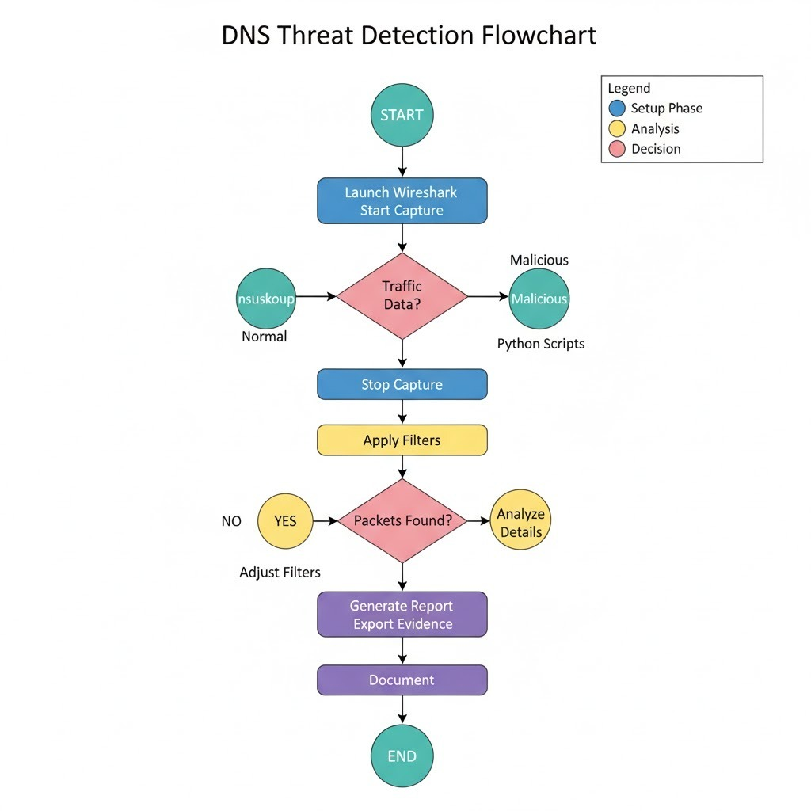

DEMONSTRATION

Open Wireshark, start capturing on your Wi-Fi interface, and generate DNS traffic by browsing websites
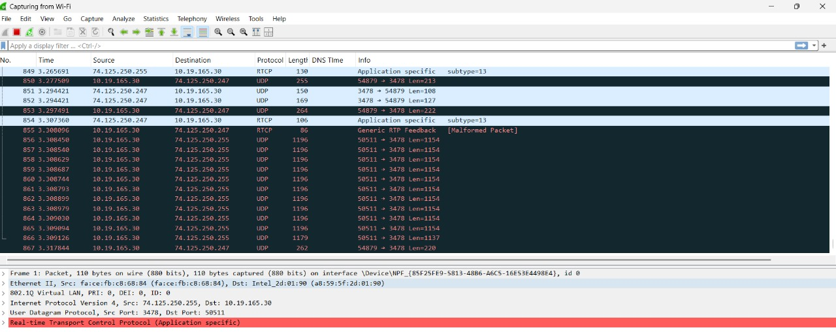

The filter dns && frame.len > 400 in Wireshark displays DNS packets larger than 400 bytes. This is useful for spotting unusually big DNS requests or responses, which may indicate suspicious activity
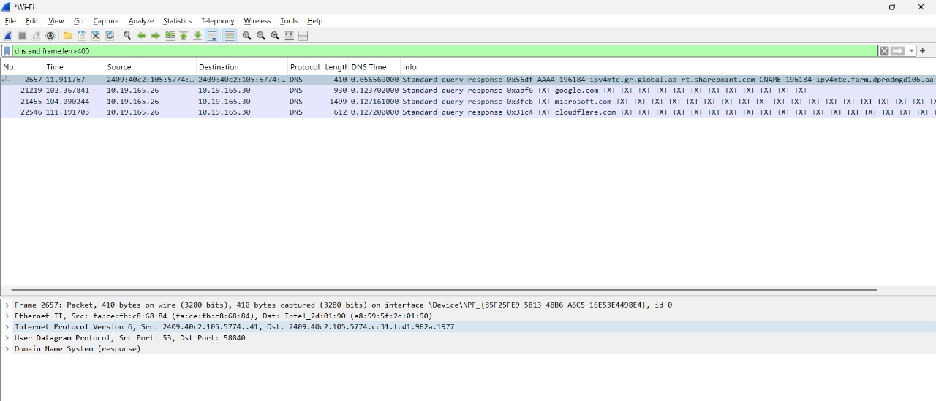

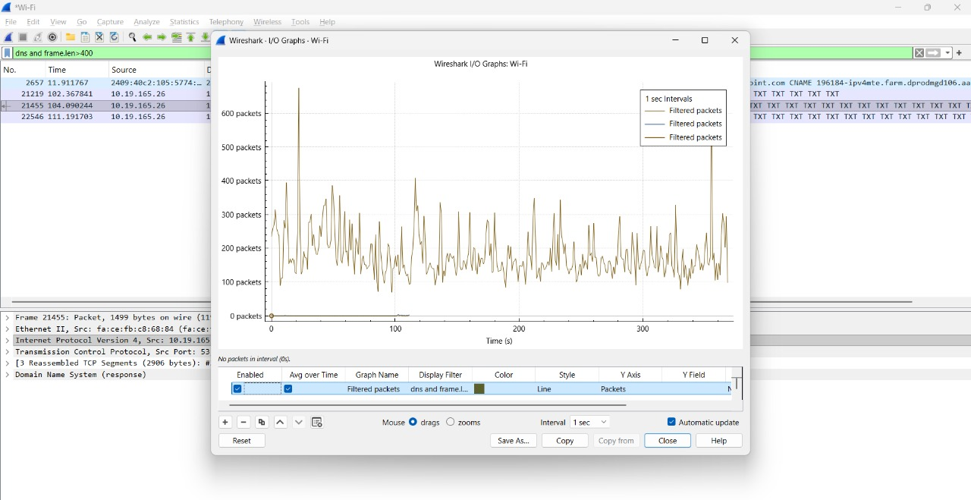
I/O Graph(depicts network traffic statistics over time)

The command dns.flags.response == 1 && dns.count.answers > 1 is used in Wireshark to filter and display DNS response packets that contain more than one answer. This helps identify suspicious responses that might indicate DNS spoofing
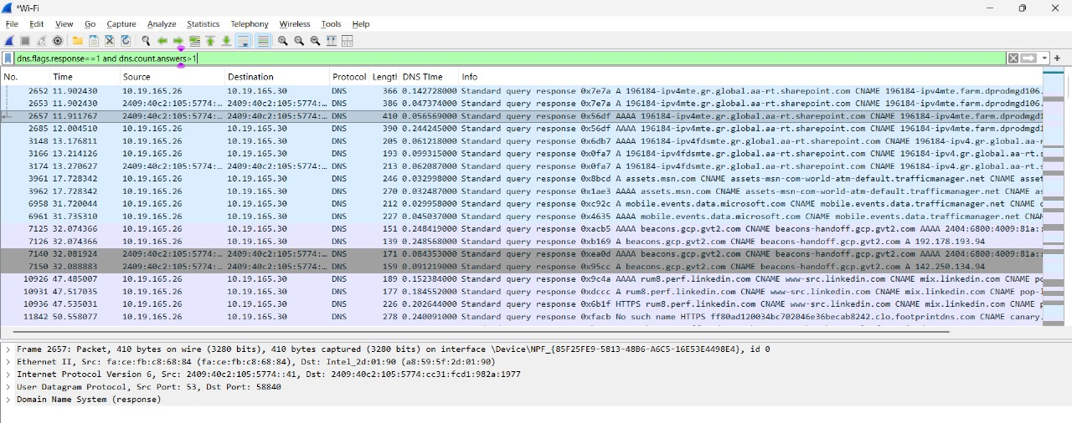

The filter dns.resp.ttl <= 60 in Wireshark shows DNS responses with a low TTL (time-to-live) value. Low TTLs can signal suspicious or spoofed DNS records, often set by attackers so fake information expires quickly.
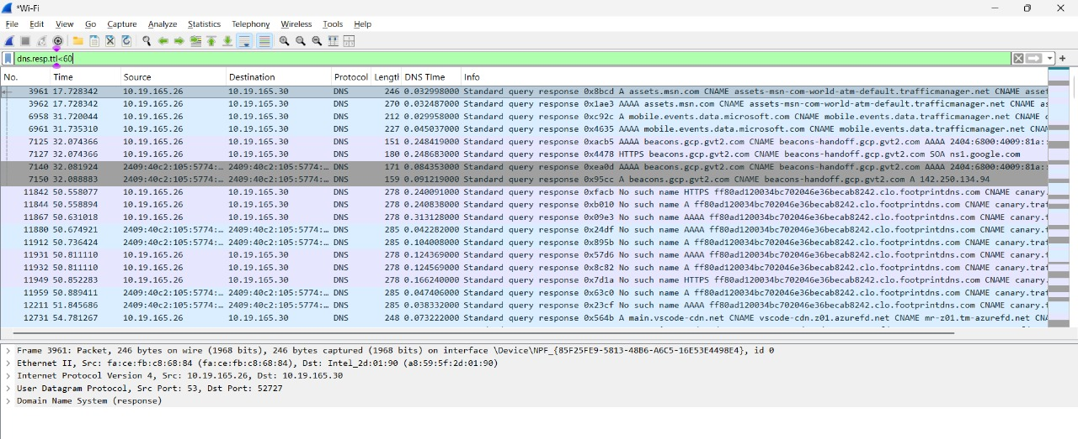
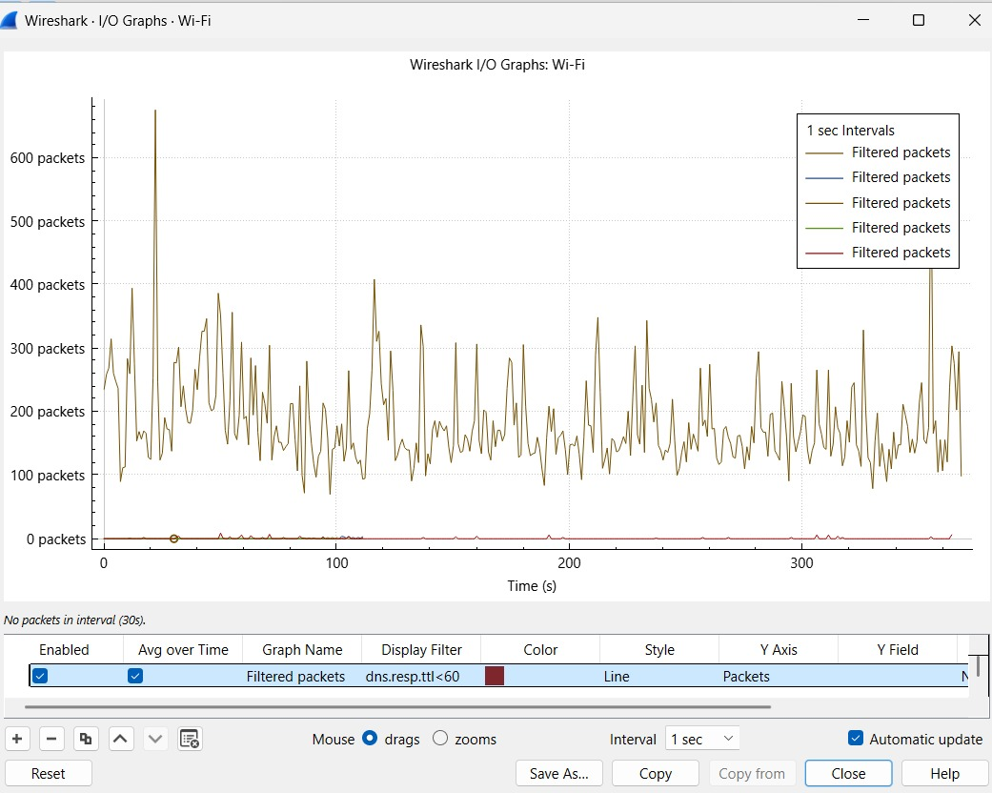

The filter dns.qry.name matches ".[0-9a-f]{32,}." finds DNS queries with very long hexadecimal subdomains. These often signal hidden or encoded data, a common sign of DNS exfiltration.
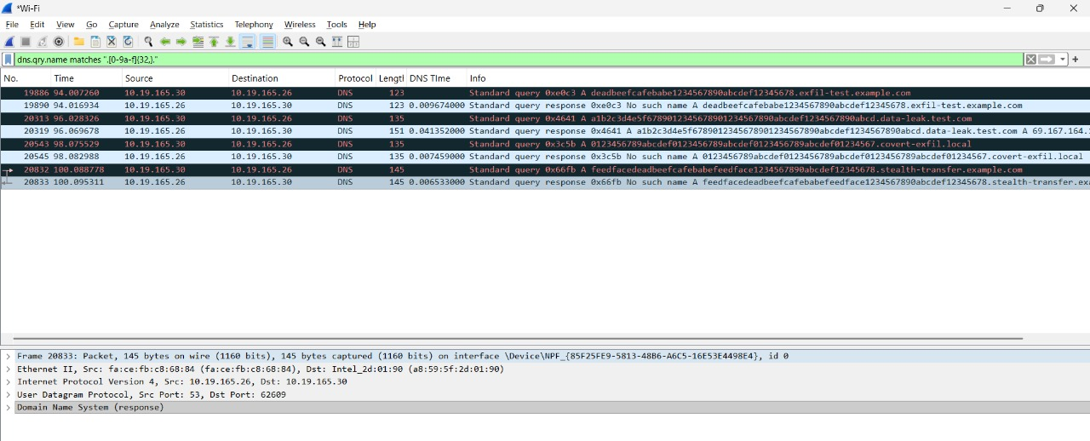
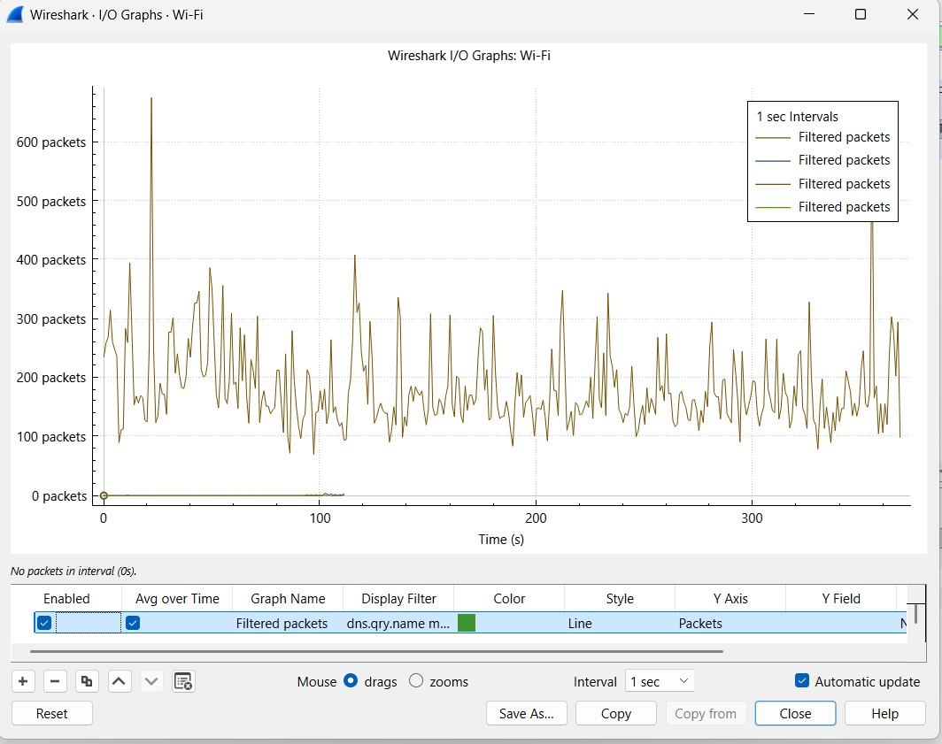

The Wireshark filter dns.qry.type == 16 displays DNS packets where the query type is TXT (text record).TXT records can be abused to hide or transfer extra data, often used in DNS tunneling or data exfiltration attacks
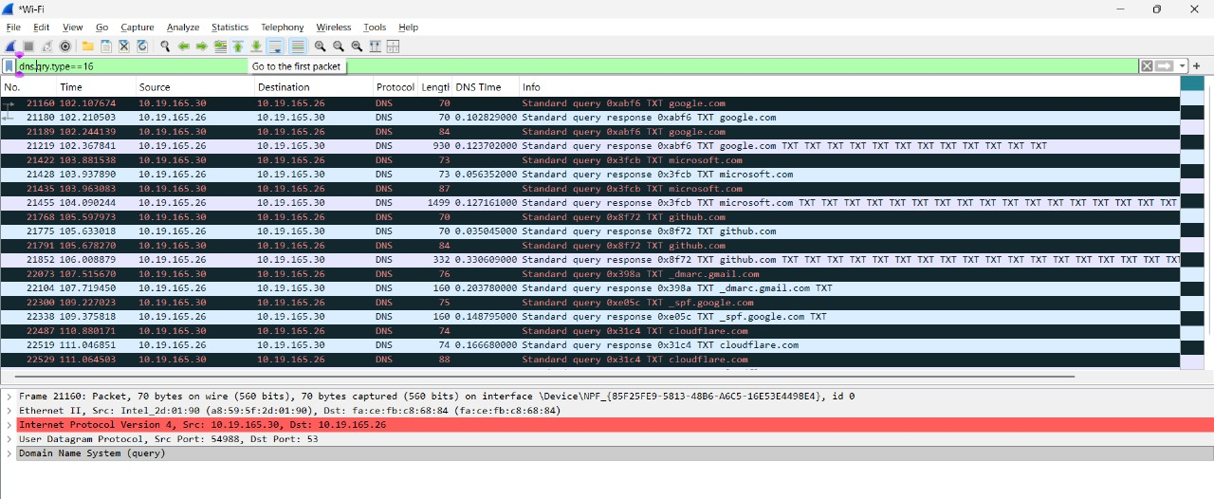

Observations
During the analysis, DNS packets with unusually long subdomains and repetitive encoded sequences were detected, indicating possible DNS tunneling. DNS responses with mismatched IP addresses suggested spoofing activity.

Result / Output
Successfully simulated and detected DNS tunneling, spoofing, and data exfiltration using Wireshark. Effective identification of malicious DNS traffic was achieved through the use of filters and traffic pattern analysis.

Conclusion
This experiment provided insights into DNS-based cyber threats and how network monitoring tools like Wireshark can be used to identify and reduce such attacks. Understanding DNS traffic behavior is essential for improving network security and preventing data breaches.

--------------------------------------------------------------------------------------------

Viva Questions
1. What is the role of DNS in network communication?
2. How can Wireshark be used to detect DNS tunneling?
3. What are the key signs of DNS spoofing in network traffic?
4. How does DNS data exfiltration differ from tunneling?

